Name_____________________Hour___
Analyzing the Phases of the Cell Cycle
- Describe what is happening in a cell during each phase of the Cell Cycle:
- Interphase:

- Prophase:

- Metaphase:

- Anaphase:

- Telophase:

- Cytokinesis:

- In which stage are each of these cells:
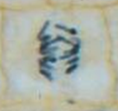
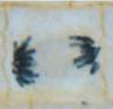
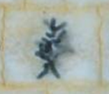
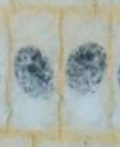

- Observe the microscope slide below of a growing root tip.
- Identify each cell with the stage of the cell cycle that you think it is in,
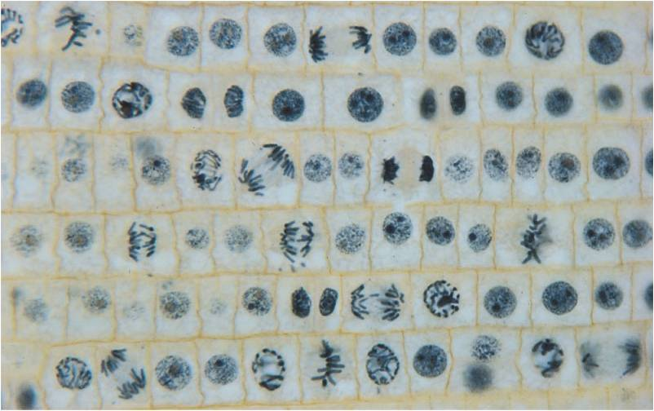
labeling each with I, P, M, A, T or C.
- Using the data table, count how many of each there are.
Phase of Cell Cycle | Number of Cells | % of Cells in Stage
Interphase
Prophase
Metaphase
Anaphase
Telophase
Cytokinesis

- Analysis Questions:
- Which phase had the most cells?

- Does it make sense that the phase you indicated above had the most cells? WHY?

- What evidence shows that the cell cycle happens as a continuous process and not a series of separate events?

