Chapter 4: Integumentary Organ System
I. We will consider 3 membrane types in this unit:
A. Cutaneous Membrane – skin
B. Mucous Membranes – line body cavities that are exposed
to the exterior environment.
C. Serous Membranes – line body cavities that are NOT
exposed to the exterior environment.

II. Membrane Structure & Function:
- Structure - Made of an epithelial sheet and an
underlying connective tissue layer.
*Considered “organs” because made of ≥2 tissue types.
B. Functions:
1. Cover surfaces
2. Line body cavities
3. Form protective sheets around organs
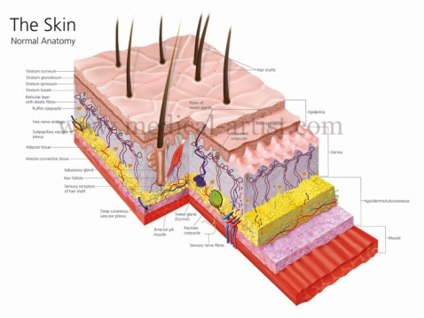

III. Each type in a bit more detail:
A. Cutaneous Membranes
- Aka “skin”.
- Dry stratified squamous
epithelium on the outside.
- Dense fibrous connective tissue underneath.
- MUCH more to come on this one later!

- Mucous Membranes
- Lines body cavities that are exposed to the external environment (stomach, lungs, bladder, etc.).
- Stratified squamous or simple columnar epithelium as the top layer.
- Loose connective tissue layer underneath.
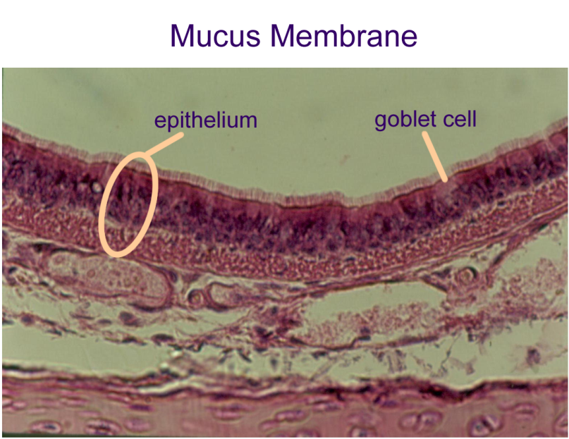
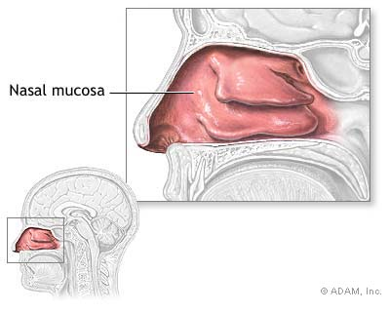

- Serous Membranes
- Lines body cavities that are not exposed to the external environment.
- Always occurs as paired sheets:
*Parietal sheet – lines inside of body cavity wall.
*Visceral sheet – lines outside of organ.
(These sheets are separated by a thin layer
of serous fluid for lubrication)
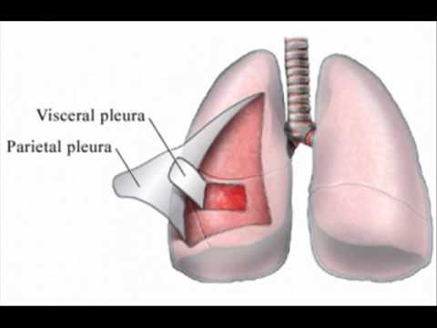
- Made of simple squamous epithelium and areolar connective tissue
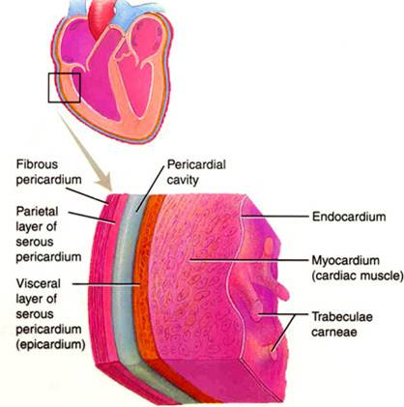

Assn: p109 Multiple Choice #1,2
p109 Short Answer Essay #1-3
p110 At the Clinic #1

III. Skin
- Functions as protection, insulation, hydration
- Largest organ of the body
- ~20lbs; 22ft²; 1.6 trillion cells
- Lose 30,000-40,000 cells/hr; 8#/yr
- Two main layers:
- Dermis
- Deep layer
- Dense fibrous c.t.
- Blood vessels, glands (sweat/oil/sebaceous), nerves
- Live cells
- Collagen and elastic fibers (waterproofing & elasticity)

- Epidermis
- Superficial layer
- Strat. squam. Epithelium
- Avascular - no blood supply
- Five strata (layers); only the deepest stratum is alive (stratum basale)
- Cells migrate up from the stratum basale and become keratinized (tough & waterproof)

- As the cells get farther from their blood supply and more keratinized, they die and are shed
*completely new epidermis every 25-45 days

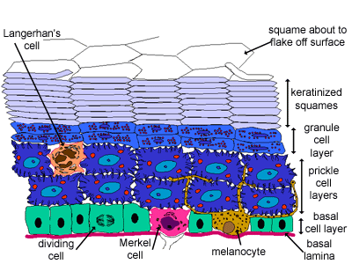
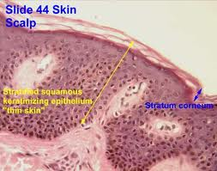
- Contains melanocytes which make melanin
*yellow/brown/black in color
*repairs sun damage
P109 MC #1,2; SAE#1-4;p110ATC#1,3

- Skin Color
- Determined by 3 pigments
- Melanin – yellow/brown/black
- Carotene – orange/yellow
- Oxygen content on hemoglobin – red
- Contusions (blood pooling under skin) – purple

- Abnormal colors
- Erythema –red from fever/allergies/inflammation
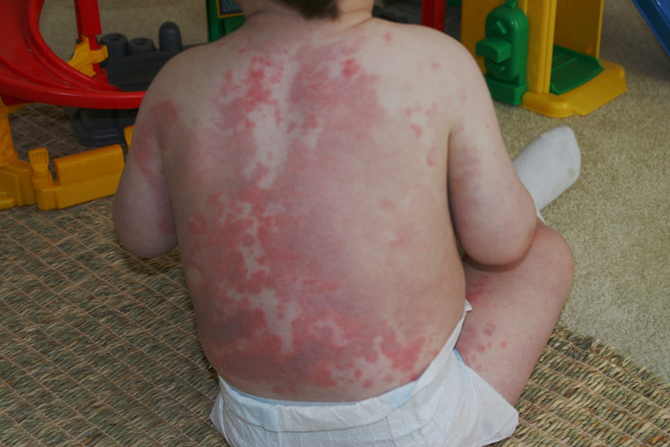

- Pallor – white from low blood pressure/anemia/shock
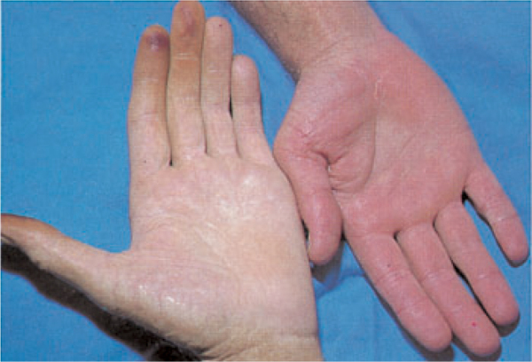

- Jaundice – yellow from lack of liver function
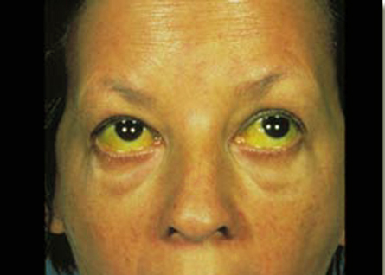

III. Skin Appendages
- Cutaneous Glands (all exocrine)
- Sebaceous Glands
- Produce oil called sebum
- Acidic, so kills bacteria
- Clogged sebum duct = zit
- Sweat Glands
- Water, salts, vit. C, ammonia, uric and lactic acids
- Removes body heat

- Hair
- Epithelial cells in follicle divide rapidly to form root
- Dead epithelial cells pushed out to form shaft
*shaft shape (oval/ribbon/round) determines curliness
3. Single muscle (arrector pilli) attached to every follicle

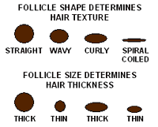

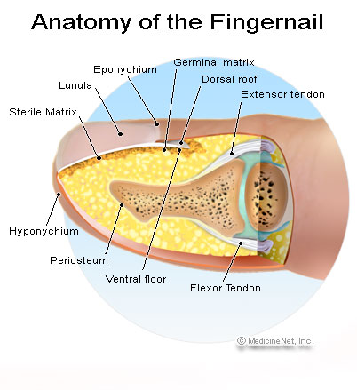
- Nails
- Free edge, body, root
- Cells made in root keratinize,
die, pushed out
- Provide “window” into
- body’s health:
- Pink = good
- White = insufficient blood
- Blue = low blood oxygen
- Capillary refill = blood pressure

Assn: p109 Multiple Choice #3-7
p109-110 Short Answer Essay #4-9
VI. Tissue Damage & Repair
A. Three lines of defense against damage:
1. First defense: two layers of integument
a. Stratified Squamous Epithelium in Epidermis
- Many “sacrificial” layers of dead cells
b. Dense Fibrous Connective Tissue in Dermis
- Tough layer
2. Second defense: Inflammation
a. More blood is pumped to the damaged area.
b. Blood brings healing nutrients and carries away damaged cells.
c. Area swells and becomes red and warmer.
d. Generalized response.
3. Third Defense: Immunity
a. Response to pathogens (bacteria, viruses, toxins, foreign bodies)
b. Specific response.

B. Tissue Repair
1. Steps in Tissue Repair
a. Clotting proteins sense wound and link up to form long strands.
b. Strands catch on wound edges and form “net” to trap blood cells.
*this is what we call a “clot”!
c. Granular Tissue fills in wound.
-delicate, capillary-rich, generalized tissue to knit edges together.
-first (living) layer of epidermis forms under granular tissue and
begins to generate more layers of epidermis.
-growing epidermis pushes scab (dried G.T.) from wound.

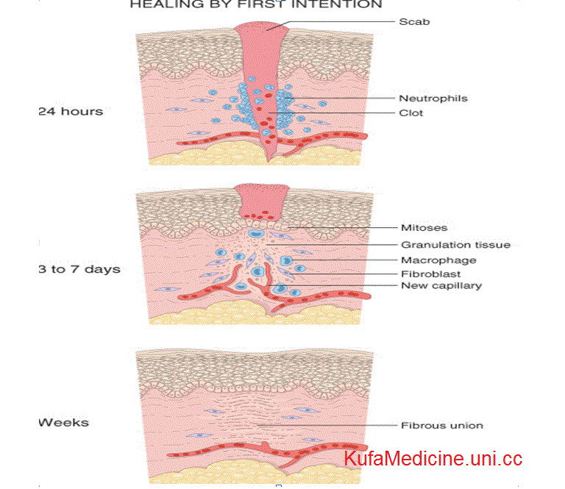
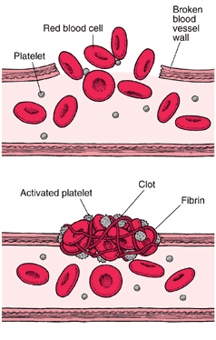

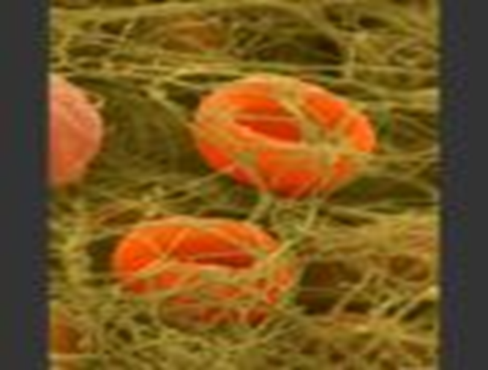

2. Two Mechanisms of Tissue Repair
a. Regeneration
- Damaged tissue is replaced by original tissue type.
- Small wounds and wounds with clean edges.
- No scarring
b. Fibrosis
- Damaged tissue is replaced by Dense Fibrous Connective Tissue
- Large wounds and wounds with jagged edges.
- Scarring occurs.

C. Burns – skin cell destruction from heat, electricity, chemicals or radiation.
1. Two major complications of burns:
a. fluid loss from injury
b. infection from bacteria and fungi

2. “Rule of Nines”
a. Body surface divided into 11 areas: each representing ~9% of body surface.
b. see fig 4.9 (p104)

3. Classification of Burns
First Degree | Second Degree | Third Degree
Only epidermis damaged | Epidermis & upper dermis damaged (appendages still intact) | Epidermis, dermis and appendages destroyed
Red & swollen | Blisters | Gray / black
Moderately painful | Very painful | Relatively painless
No scarring | Little scarring | Much scarring
Heals in 1-3 days | Heals on own in 3-4 weeks | Will not heal on its own

4. Burn is Severe if:
a. ≥25% of body is 2nd degree
b. ≥10% of body is 3rd degree
c. third degree is present on face, hands, feet
- Face = respiratory damage
- Hands & feet = joint immobility

