Evolution – change over time

*Theory = explanation based on much evidence
(do not confuse with “hypothesis”)
*Not goal-oriented (can change and change back in
response to environment)

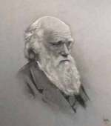
- History

A. Charles Darwin (1809-1882)
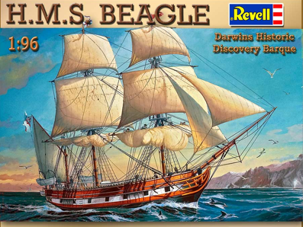
- Sailed on the HMS Beagle for 5 years starting in 1831.
- Visited many places around world and carefully observed living things.
- Collected and compared many plants and animals.
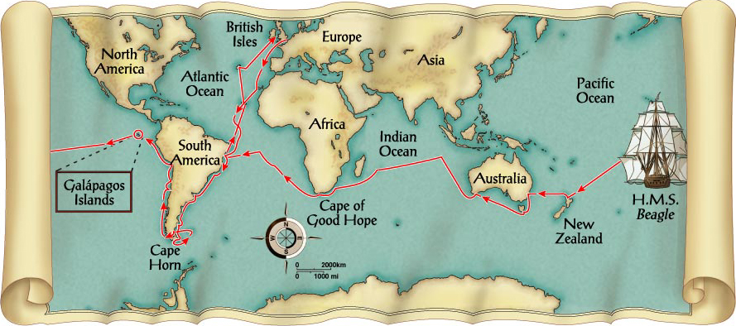
B. Galapagos Islands
- Darwin’s most important visit.
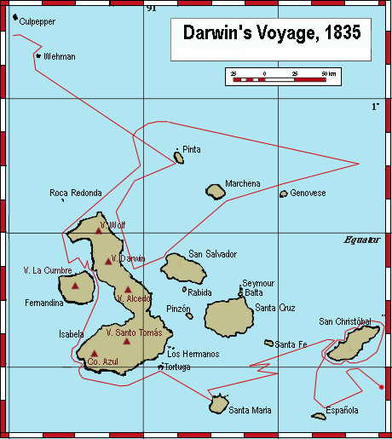
- A group of small islands west of South America, each with unique environments and living things.

- Organisms on each island fit their environments.
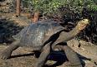
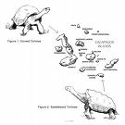
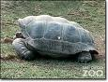

  - Adaptation = physical or behavioral trait that enables an organism to survive.
Ex) Defensive structures (teeth, thorns, etc)
Camouflage
Mimicry (harmless resemble harmful)
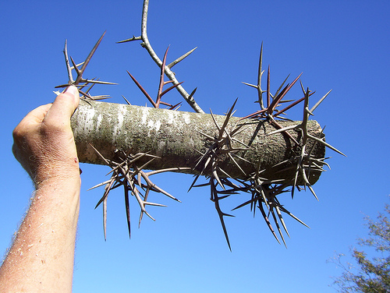
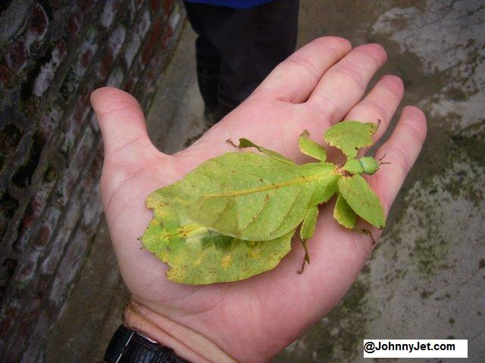
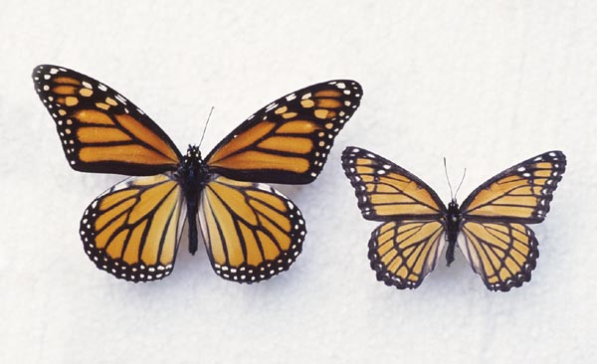

  - Darwin’s Finches – small birds on each island
from a common ancestor but changed beak shape
according to food type.
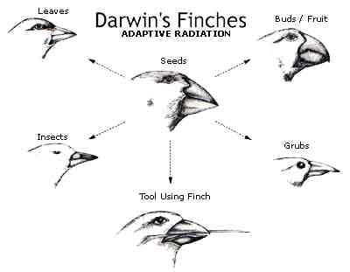
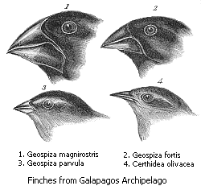
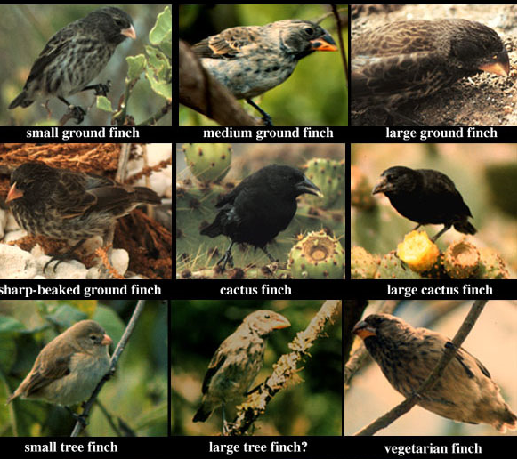

C. Origin of Species
1. Darwin’s book published in 1856.
2. Described his theory that all living organisms are
constantly changing in response to their environment.


