- Three Mechanisms of Change – Natural, Sexual and
Artificial Selection
A. Natural Selection (Mechanism #1)
- A process of selection in which the organisms best suited to their physical environment survive to pass along their genes.
- Often summarized as “Survival of the Fittest”.
Fitness, in this case, refers to an organism’s ability to
survive in its environment and pass along its genes to
the next generation.

- Organisms that survive selective pressures (disease, predators, etc.) will pass along their genes.
- Different environments have different selective pressures, so new species evolve over time.
- Genetic variation in nature provides a range of traits to choose from during natural selection.
Ex) leg length in deer
Ex) shoe sizes in a class

B. Sexual Selection (Mechanism #2)
- A process of selection based on traits that give an organism an advantage in finding a mate and passing on its genes.
- Traits good for sexual selection may be bad for natural selection. Called the “Handicap Principle”.
Ex) flashy colors, large clumsy feathers,
bird songs, sagging, etc.
*May show a potential mate that “I am so healthy
that I can survive even with this clumsy
decoration, so you should have babies with me!”
- Males are usually the ones who display unusual traits to attract females.
Ex) peacock’s feathers, lion’s mane, etc.

C. Artificial Selection (Mechanism #3)
- Process of selection in which humans choose which traits are passed to offspring.
- Used in crops, livestock, pets.
- Because of the variation of a trait within a species, we can choose the variation we want to increase.
Ex) Cross the biggest tomatoes in a garden to
produce a next crop of bigger average size.

- Causes of Speciation – what causes a species to change?
A. Geographic Isolation (video1, video2)
1. If a species is separated by mountains, water, etc., and
the selective pressures are different, then each
population may change into its own unique species.
2. Examples: Darwin’s finches
Post-Pangea continental drift
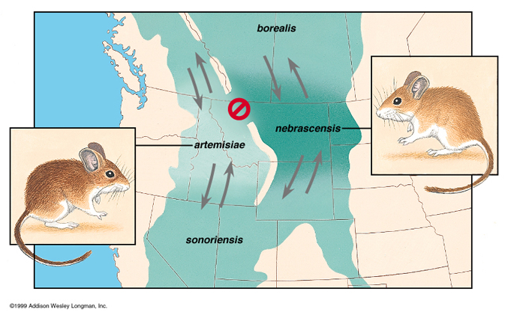
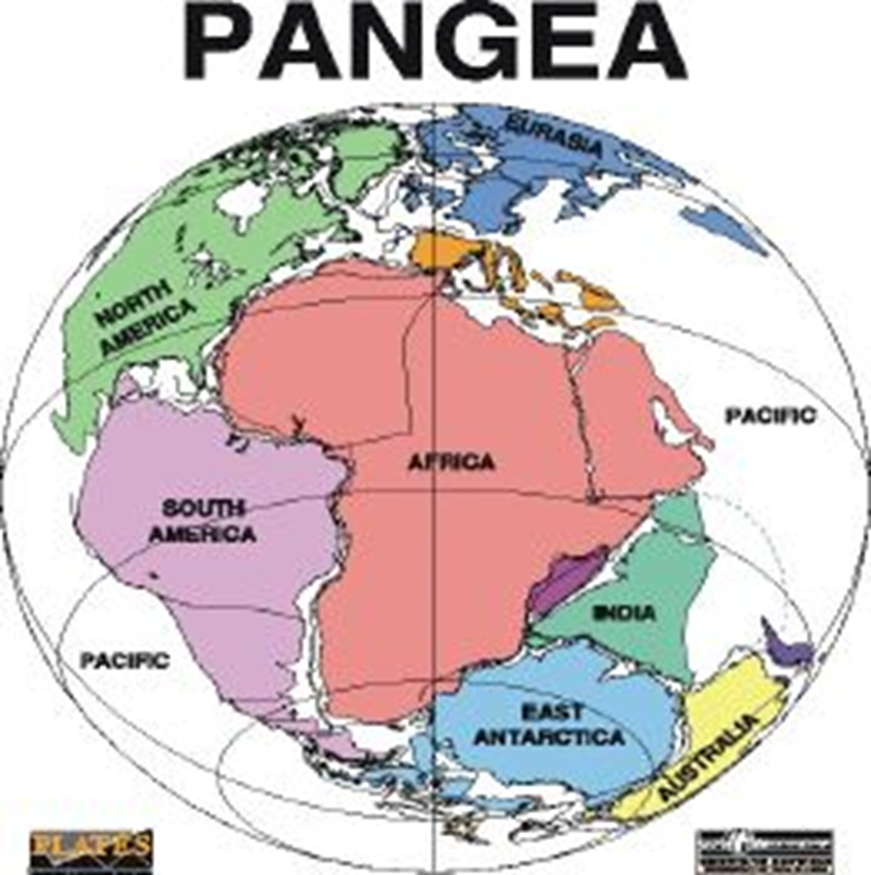
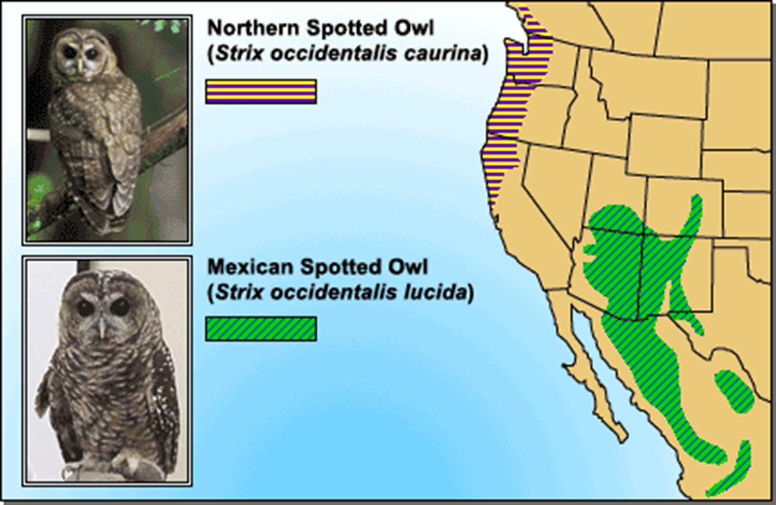

B. Behavioral Isolation (video1)
- Two populations of a specie may begin to behave differently or mate at different times, causing them to develop into two new species.
- Examples: Slightly different bird calls
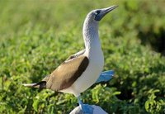
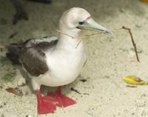
Frogs that mate a week apart

C. Mutations / Genetic Drift
- DNA always changes a little between generations.
- Sometimes these random changes help the organism and are passed to the next generation, causing the species as a whole to change.
- Ex: Peppered Moth

- Types of Evolution
A. Adaptive Radiation
1. A single species which has evolved into several
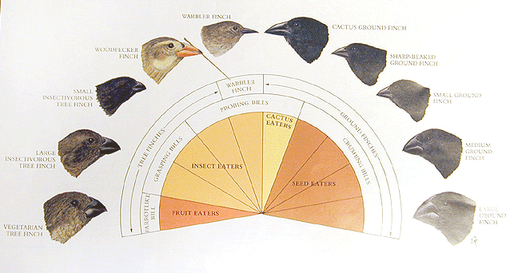
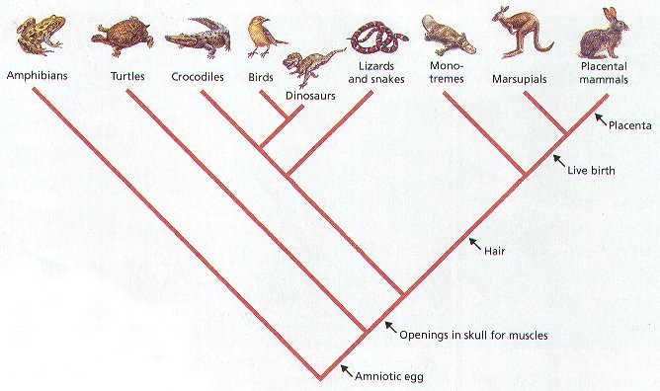
different species living in different ways.

Ex) Darwin’s Finches

B. Convergent Evolution

- Unrelated organisms evolve to look similar to each other because of similar selective pressures.
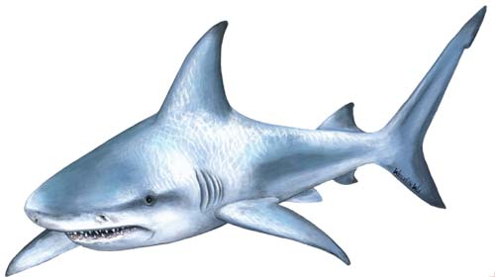
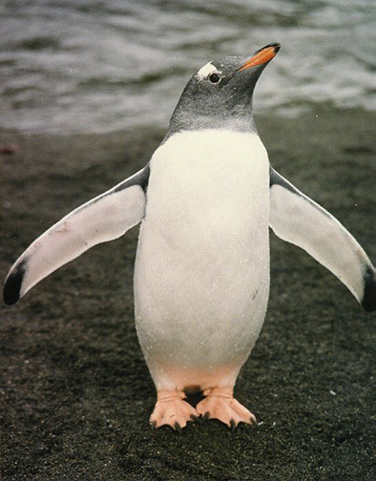
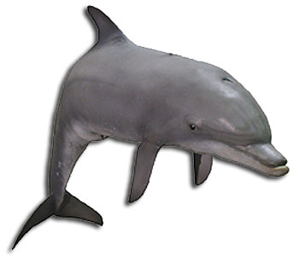
- Ex) “flippers” in sharks, dolphins, penguins, seals

C. Coevolution
- Two species living closely together evolve together.
- One is a selective pressure on the other.
- Ex) clown fish & anemone
Ex) predator & prey (“Evolutionary Arms Race”)


