- Overview of the Cardiovascular System

- Major function: transportation
- O₂, nutrients, wastes, hormones, etc.
- Uses blood to carry things
- Three major components: heart, vessels, blood

- Heart
- One-pound, fist-sized muscular pump with
one-way valves.
- Pumps about 4,000 gallons of blood daily.
- Inferior (pointy) end called the “apex”;
superior (blunt) end called the “base”.

- Covered with two layers of pericardium with
fluid in between (lubrication).
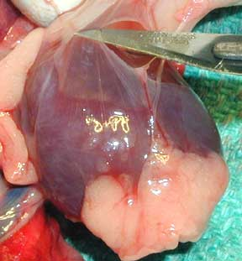
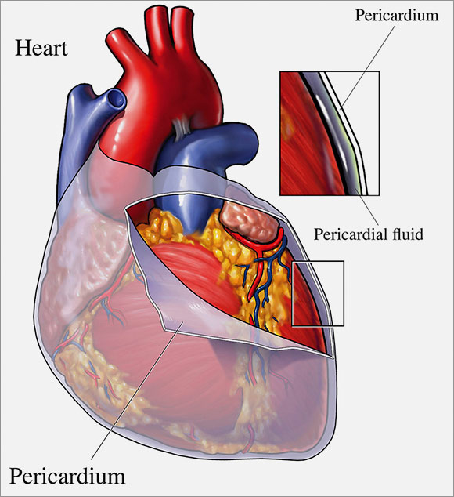

- Heart walls made of three layers:
- Epicardium – outside layer
- Myocardium – middle layer (cardiac muscle)
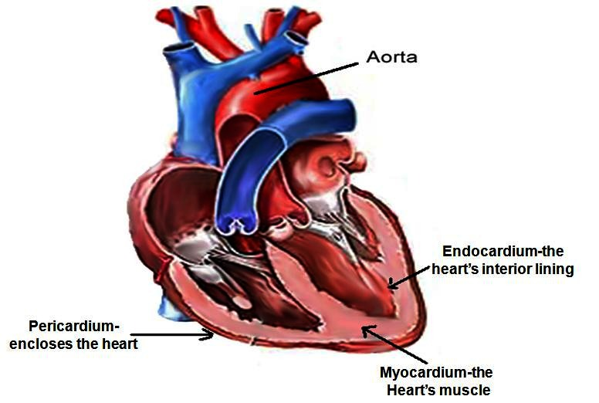
- Endocardium – inside lining

- Four hollow chambers (2 atria & 2 ventricles)
- Atria – receiving chambers (not muscular)
- Ventricles – sending chambers (muscular)
- Right A&V – pulmonary circulation
- Receive O₂-poor blood from body.
- Sends O₂-poor blood to lungs to get O₂.
- Left A&V – systemic circulation
- Receive O₂-rich blood from lungs.
- Sends O₂-rich blood to body.
- Blood Flow through the Heart
- Pulmonary Circulation (RA RV PA lungs PV)
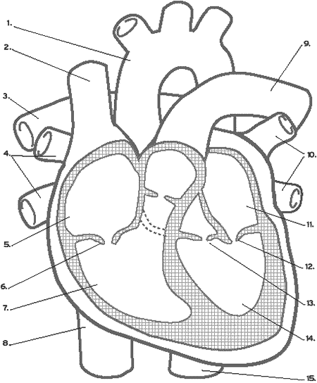

- Systemic Circulation (LA LV aorta body VC)

Assn: p.348-349 Multiple Choice #1,7
Short Answer Essay #1,3,4,5,7
Cardiovascular System Packet #1,2,3,6

