IV. Heart Stimulation & Sounds

- Cardiac muscle can contract on its own without any stimulation, but needs to be synchronized.

- Two systems control heart activity:
- Intrinsic Conduction System
- Special tissue makes heart contraction in one-way wave (atria ventricles)
- Sets pace at 75 bpm
- Sinoatrial (SA) node
- Creates initial impulse of heartbeat
- Our natural “pacemaker”
- In right atrium of heart
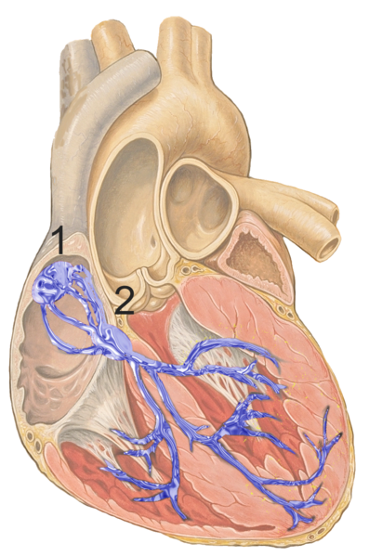

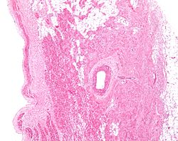

- Brain Control
*brain acts like brakes / accelerator to modify basic
rhythm set by ICS depending on body needs.

- Heart Sounds
- Cardiac cycle = one complete heartbeat (~0.8sec)
- Contraction of ventricle = systole
- Relaxation of ventricle = diastole
- Beat makes “LUB-DUP” sound from valves closing
- “LUB” = closing of tricuspid & bicuspid valves
- “DUP” = closing of aortic & pulmonary semilunar
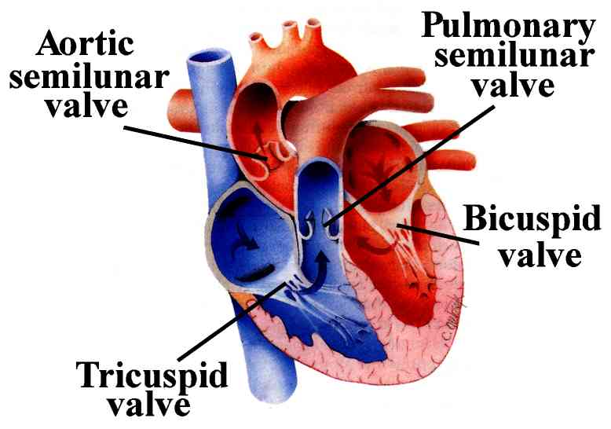
valves.
- Leaky valves let some blood flow backward, making a gurgling sound called a “heart murmur”.
