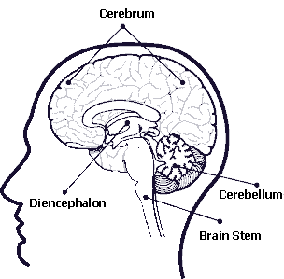
IV. BRAIN STRUCTURE & FUNCTION

- Four main regions of the brain:
- Cerebrum
- Diencephalon
- Brain Stem
- Cerebellum

- Brain Regions in Detail
- Cerebrum
  - Largest visible area
  - Ridges (gyri) & grooves (sulci)
  - Split into right & left hemispheres
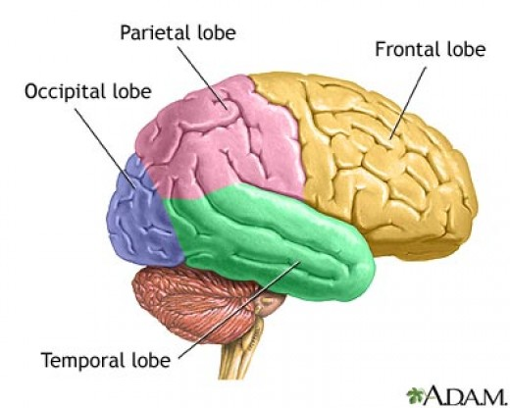
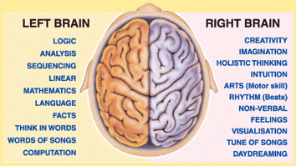
  - Divided into several “lobes”

  - Responsible for:
- Speech
- Memory
- Logical thought
- Emotions
- Voluntary movement
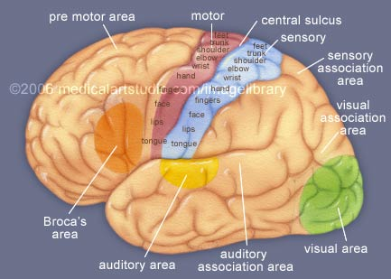
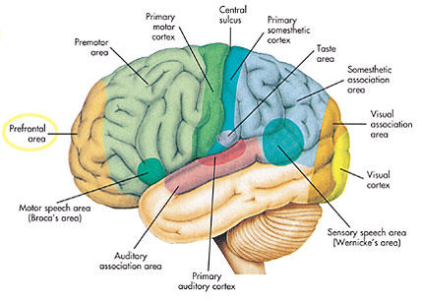
- Senses

  - Outer area called “gray matter”
- Unmyelinated nerves
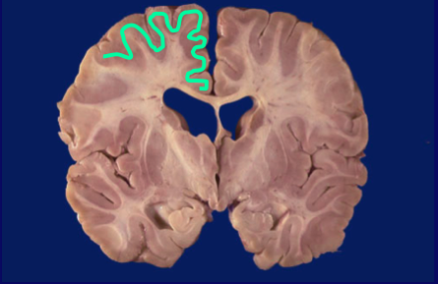
- Where all functions in “e” happen.

  - Inner area called “white matter”
- Carries messages throughout cerebrum
- Corpus callosum – fibers that connect cerebral
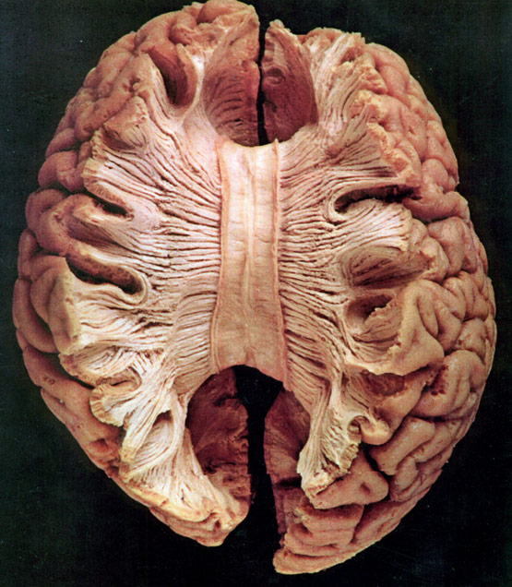
hemispheres.
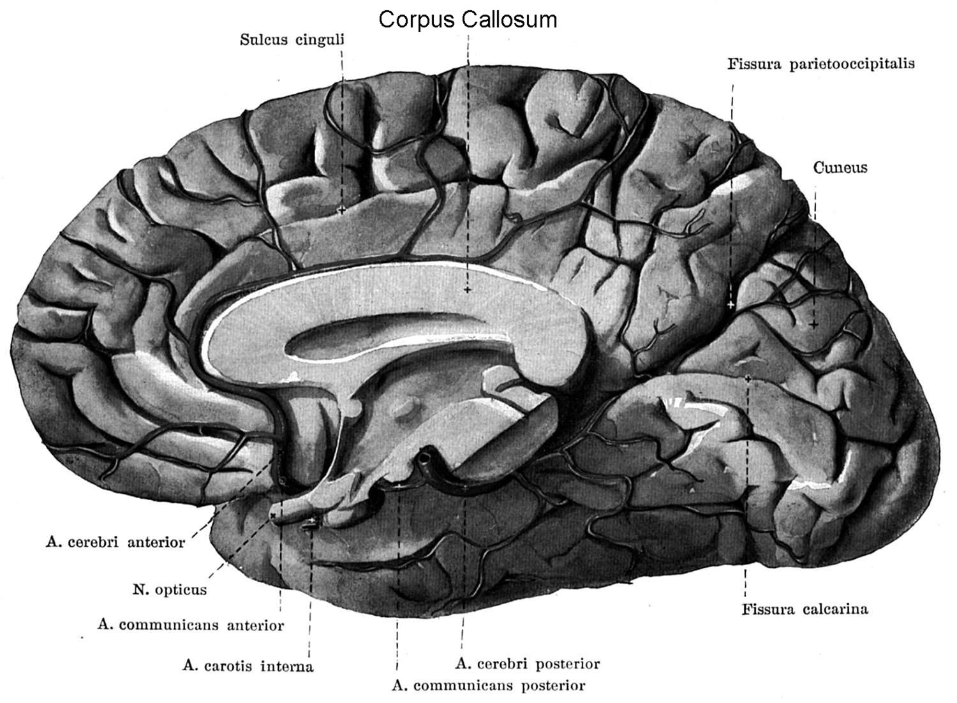

- Diencephalon
  - Inside cerebrum
  - Major structures:
- Thalamus – tells if sensations are good or bad
- Hypothalamus – regulation of body
temperature, water balance,
metabolism
- Epithalamus – makes cerebrospinal fluid (stay tuned)
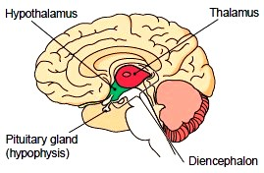
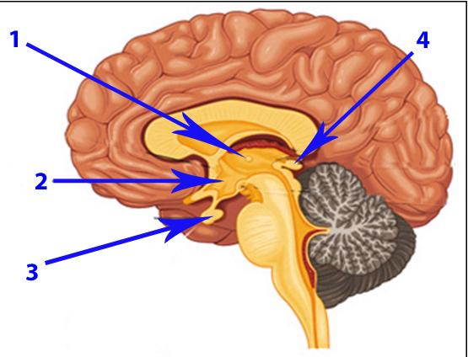

- Cerebellum
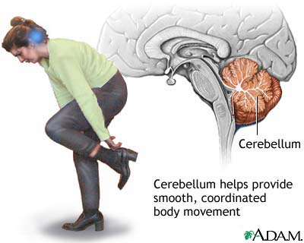
  - Fine motor control and balance

- Brain Stem
  - Three regions:
- Midbrain – vision & hearing reflexes
- Pons – breathing control
- Medulla – heart rate, blood pressure,
swallowing, vomiting
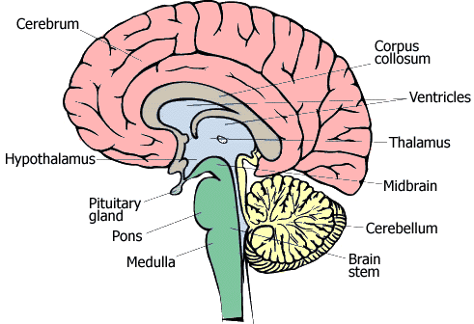

- Cranial Nerves
- Twelve motor nerves that emerge directly from brain.
- Control sense organs and muscles of head, neck, viscera.
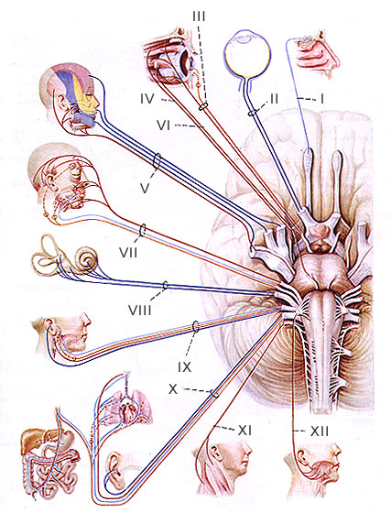
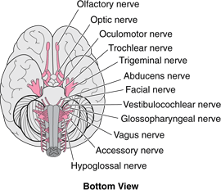

Assn: Pleasure Me, Pleasure Me! Article & questions

