DRIFTWORMS INSTRUCTIONS: Work in pairs. Each pair needs 5 different colored pencils/markers and a die.
This activity simulates genetic drift, or how percentages of different genes can change in a population.
These worms are all members of the same species. They come in different colors, but the colors don’t seem to give them advantages in their environment – they are selected for.
One worm of each color has been isolated due to flooding after a major storm. What will happen to the population?
1. First, color each worm in generation 1 a different color.
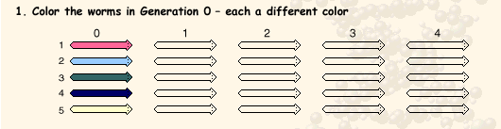
2. Now the worms reproduce. These ones do so by just cloning themselves – no other parent is involved. Remember, there is no selection for one color or another. This is random – some worms get to have more offspring than others in any generation (due to availability of food, random death, etc).
3. Roll the dice five times to see which worms have offspring this generation. (If you roll a 6, roll again – only the numbers 1-5 count). Draw a dot next to each worm that reproduces, each time.
Example: If you roll a 2, 3, 4, 2, and 5, then worm 2 has 2 babies; worms 3, 4, and 5 each have one; and worm 1 has zero.
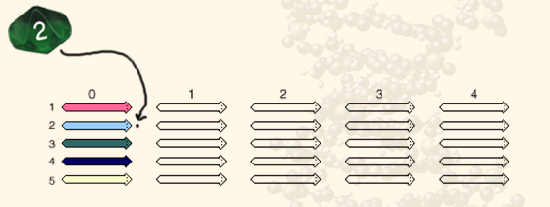
4. For each offspring that each worm has, draw an arrow to a worm in the next generation. This is its baby that it passes its color on to. Color it the same as the parent.
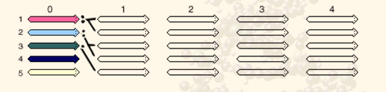
5. Repeat steps 2-4 for each generation until all the worms are the same color.
Name: _______________________________________________ Hour: __________________
Date Due: _____________________________________ Date handed in: ____________________
DRIFTWORMS ACTIVITY QUESTIONS:
1. What does natural selection mean?

2. What does genetic drift mean?

3. Why is this activity an example of genetic drift, NOT natural selection?

4. What are some examples of random events that can make one organism have more offspring than another?

5. What did rolling the dice represent?

6. When all the worms are the same color, what does this mean about the genes in the population? What happened to the genetic variation? (diversity)

7. How do you think your results would have been different if you had started with a larger population? (ex: 20 of each color worm) Would the colors have “died out” as quickly, or at all?

8. Using your answer to #7: what populations are more susceptible to genetic drift – large ones or small ones? Why?

9. What are examples of some populations that become isolated and go through genetic drift?

