Solving a Case with DNA and “Gel Electrophoresis”
There has been a crime. A woman was sexually assaulted and later discovered she was pregnant. However, she doesn’t know if she is pregnant by the rape suspect or her own husband. Can biotechnology help her by DNA fingerprinting?
Actual steps of gel electrophoresis: Steps in your process:
Step 1  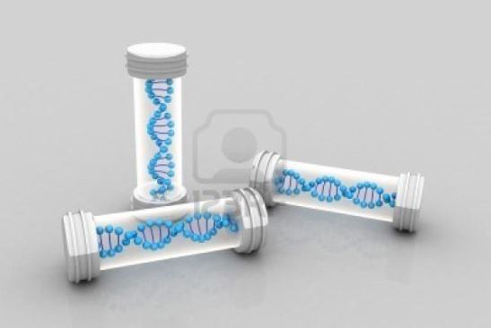  Obtain a sample of DNA from each person involved. The DNA can be taken from any cell in the body. | Step 1  Obtain your DNA samples by cutting them out from the half-page with the five samples.
Step 2  Use restriction enzymes to cut the samples up into smaller fragments. Restriction enzymes look for specific places to cut so that each sample is handled the same. | Step 2  Your “restriction enzyme” is going to be a pair of scissors. The specific place that they are going to cut the DNA samples is between the G and C of every “GGCC” sequence. This should result in 8 fragments for the Standard, and 6 fragments for each of the other four samples.
Step 3  Since the cutting results in so many DNA fragments, other enzymes are used to select specific DNA sequences to be used in the electrophoresis. Each DNA fragment should have some similarities. | Step 3  Not all of the fragments that you ended up with in Step 2 are going to be used in making the DNA fingerprint. In fact, only those with the sequence “CAT” are going to be kept. All fragments without CAT will be discarded. (No, really. Go ahead and throw them in the trash. For real.)
Step 4  The DNA fragments are loaded onto one end of a gel. An electrical current is hooked up to the gel, with the positive end opposite the DNA fragments. Since DNA has a negative charge, the fragments will begin moving across the gel. The smaller the fragment, the faster and farther it will go. When the electricity is turned off, there will be a banded pattern called a “DNA fingerprint”. | Step 4  Using the grid paper provided, glue the Standard DNA fragments from largest to smallest (remember, the smaller ones moved fastest!). now do the same for the Child, making sure that fragments of similar size to the Standard are in similar positions. Repeat for the Mother, Father and Suspect. By the end of this step, you should have a DNA fingerprint with enough evidence to determine who the father of the child is.

Police Report
On the other side of your “gel”, write a police report about your conclusions using evidence from the DNA fingerprint. Use the format that you have learned in your English classes to fully explain your verdict of who the father of the child is (the outline for this is provided below). Use your imagination…I a easily bored after reading a couple dozen of these without creativity!

