Name:____________________________________________________ Hour: __________________

EVIDENCE of EVOLUTION LAB

Area of Evidence: The Fossil Record

The domestic horse, Equus, is the only one of these animals that still exists. The dates on the first image shows when each one used to live. What conclusions could you make from what you observed above and the fact that these other animals aren’t around anymore? What do you think the picture below might mean?

Examine the following images of the fossils from the horse (species Equus) and similar species.

**Note that each image shows 5 different species, but not always the same 5 as in the other images.
Use this information to find general trends over time.

Whole Organism Skull Structure Foot Structure
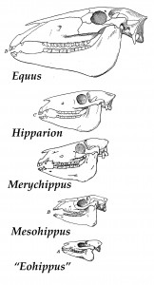
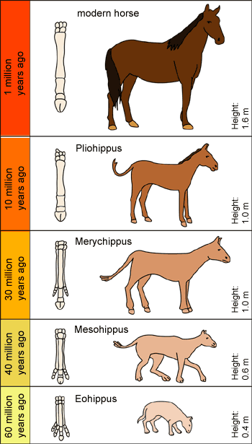
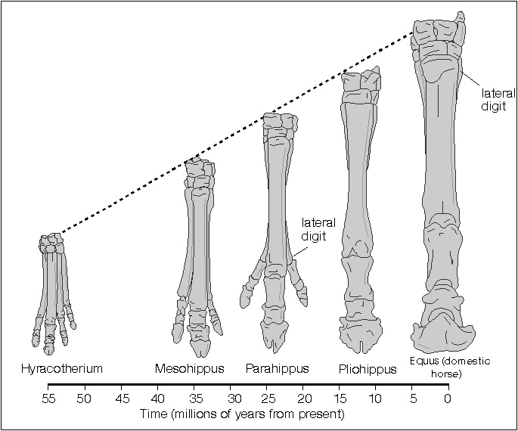

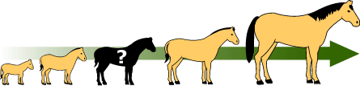

Analyzing the Fossil Record Evidence

1. List at least 4 similarities and 4 differences that you observe when comparing the modern horse to the
other horse-like animals. Organize this information in a Venn diagram:

Modern Horse (Equus) Fossils of Other horse-like animals

2. Why do you think

2. What possible conclusions about horses could you make from the evidence that you analyzed on the
previous page?

Area of Evidence: Embryology

Embryology is the study of embryos, or developing animals. Below are sketches of real observations of different vertebrate embryos at similar stages of development. (The top row is the least-developed and the bottom row is closest to being born). Note: the lines under the heads of the young animals are gills.

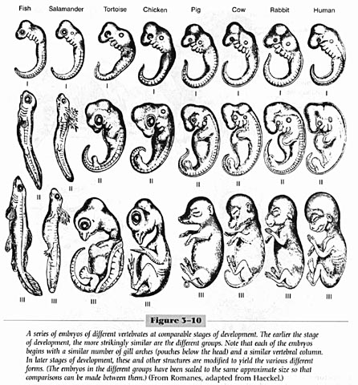
Analyzing the Embryology Evidence

1. Examine the pictures of the embryos. Which animal(s) does the human look most like when it’s close to
being born? (bottom row)

2. Which animal(s) does the chicken look the most like when it’s closest to being born? (bottom row)

3. Which animals do you think look alike when they are the least developed (top row)?

4. What are four similarities you see between all the embryos in the top row?

5. List three things you see in the human development pictures that surprise you. (think about what features
you have and what features you see in the embryo pictures)

6. What conclusions do you think a scientist might make from looking at these pictures? How does this compare to what you thought in Question #2 from the Fossils section?

Area of Evidence: Comparative Anatomy

For this part, you will use your resource sheet as well as your own observations of two animals - a bird (chicken) and a reptile ( turtle or bearded dragon).

Consider physical features such as: eyes, nose, mouth, ears, skull shape, limbs, toes, etc. You can also look at behaviors if you notice some cool similarities in your observations or reading.

List at least 10 of these features for each animal. You may include sketches if that helps! Make sure these will be things you can compare and contrast between the two.

(If you get stuck for ideas, try using the Bird and Reptile Resource Sheets on the next couple of pages)

FEATURES OF CHICKEN FEATURES OF REPTILE

BIRD RESOURCE SHEET
The chicken is a large domesticated bird. It is an omnivore that eats seeds, insects and other small animals.
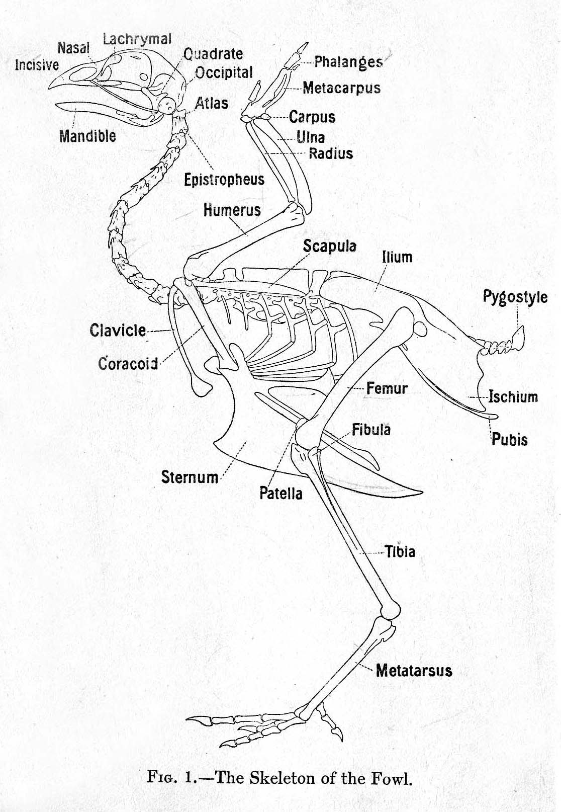

Scales
The scales of birds are composed of the same keratin as their beaks, claws, and spurs. They are found mainly on the toes and bottom part of the foot, but may be found further up on the ankle in some birds. The scales of birds are made of beta-keratin, the same as the scales of reptiles.

Bird embryos begin development with smooth skin. On the feet, the outermost layer of this skin may thicken and form scales of different sizes and thickness.

Feet
Birds can have between two and four toes arranged in different patterns, depending on the species.

Feathers
Birds have several different types of feathers on different parts of their body. Periodically, birds will shed their feathers and grow new ones; in a process called molting.

REPTILE RESOURCE SHEET
The Bearded Dragon is a lizard that can be found in arid (dry) woodlands and rocky deserts in central Australia. These lizards are omnivores both in captivity and in the wild. They will eat a variety of vegetation and insects.
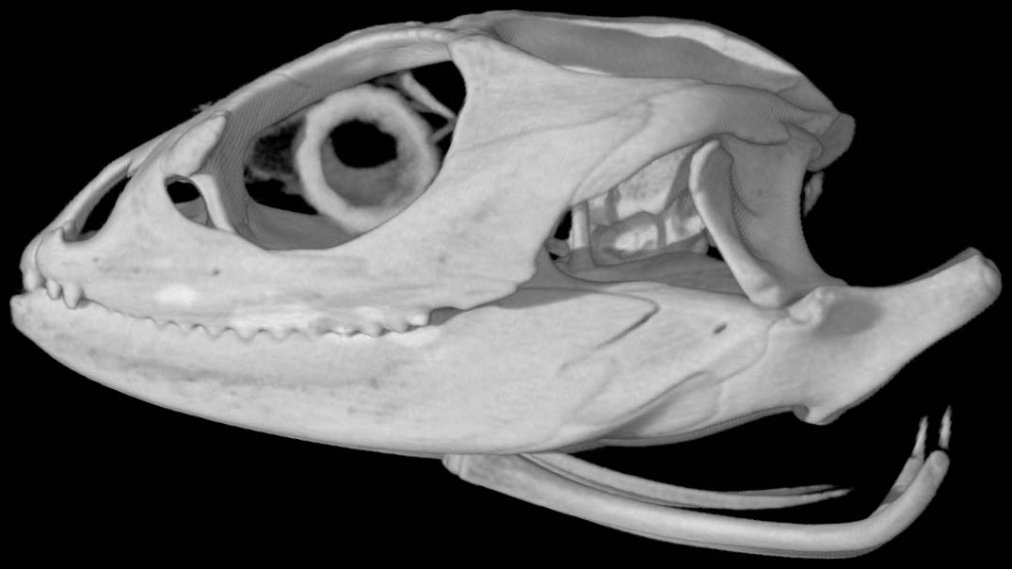

Iguanas are found primarily in Central and South America, though they are popular as pets as well. They live in forested areas near water. They are good climbers and swimmers, which helps them escape predators. They are mostly herbivorous (plant-eaters) and use a defensive head bob to scare off predators; they also display the dewlap under the neck.
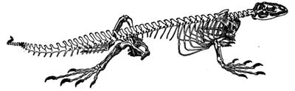
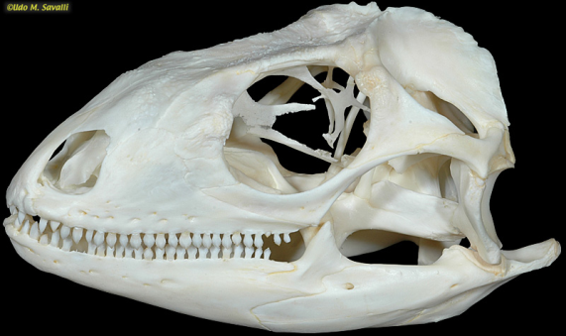

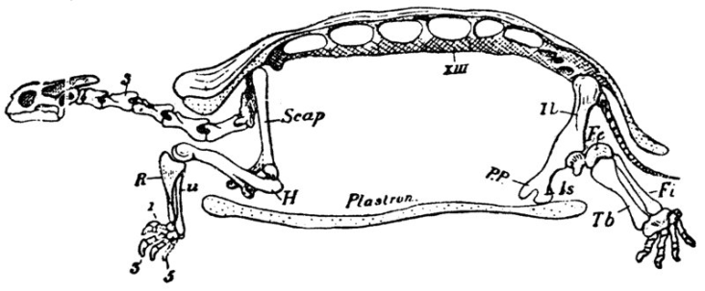
There are many species of turtles found in the United States. Some live mostly in water, while others are land animals. Their structures differ based on the environment. The basic anatomy they all share is their attachment to the shell, which protects all their organs. A turtle does not have a “back” in the way other animals do; the shell is made of modified bones that form the spine and ribs in other reptiles. This is why a turtle cannot come out of his shell!
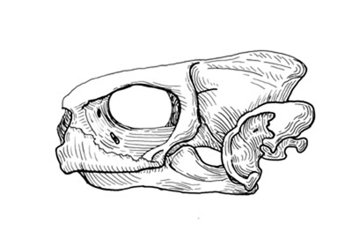
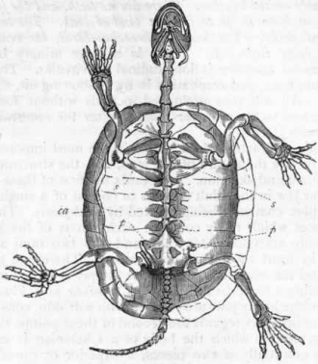
Scales
All these reptiles are covered in scales, which shed. The “beard” on the bearded dragon is made of harder spiny scales that are not very sharp but scare off predators. The bearded dragon and the Iguana also have a special scale on the top of their heads, between the eyes but farther back. It can be distinguished by a black or white dot. This scale is called a parietal eye or “third eye” and it is photosensitive, meaning it senses the difference between light and dark. Reptiles' biggest predators in the wild are birds, which attack from above. If a shadow falls across this “third eye,” these reptiles will take a defensive stance. For this reason, it is best to approach them from the front, so you do not scare them.
Analyzing the Comparative Anatomy Evidence
1. What are some features you see that reptiles and birds share? Pay special attention to the head, limbs, and
feet. You should be able to list at least five.

2. What are the most obvious differences between reptiles and birds?

3. How do you think these differences might be helpful to each animal?

4. Look at the similarities you noticed. Why do you think they might they have these similarities?

5. Look at the illustration below. This is an extinct species called Archaeopteryxwhich lived about 150 million
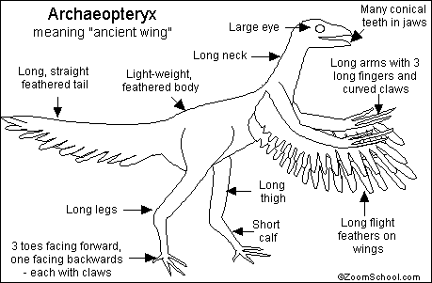
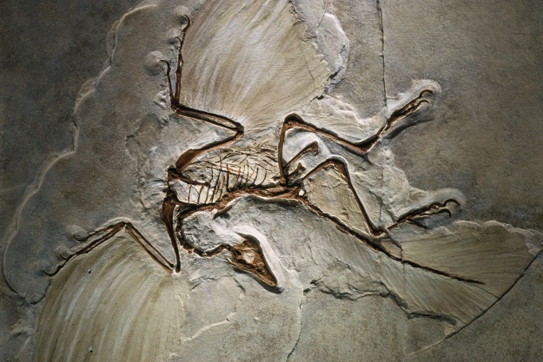
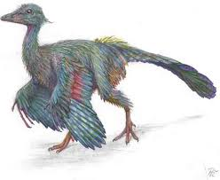
years ago. What do you see here? Do you think it is a reptile or a bird…..or something else? Explain!

