V. Blood Vessels
- Vessel walls made of 3 layers:
- Tunica intima – slick inner layer.
- Tunica media – middle layer of smooth muscle.
- Tunica externa – outer layer of fibrous connective
tissue for protection.
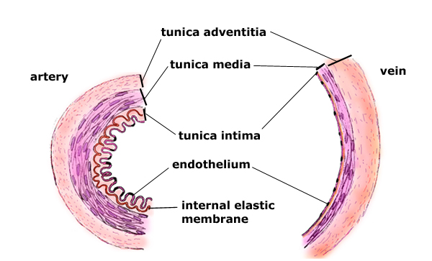
tunica externa

- Arteries - vessels that carry blood away from heart.
- Oxygen-rich blood (except for pulmonary artery).
- Arterioles – smaller arteries.
- Capillaries – smallest vessels where gas exchange
happens between blood and body cells.
- Veins – vessels that carry blood back to the heart.
- Oxygen-poor blood (except for pulmonary vein).
- Venules – small veins that drain capillaries.
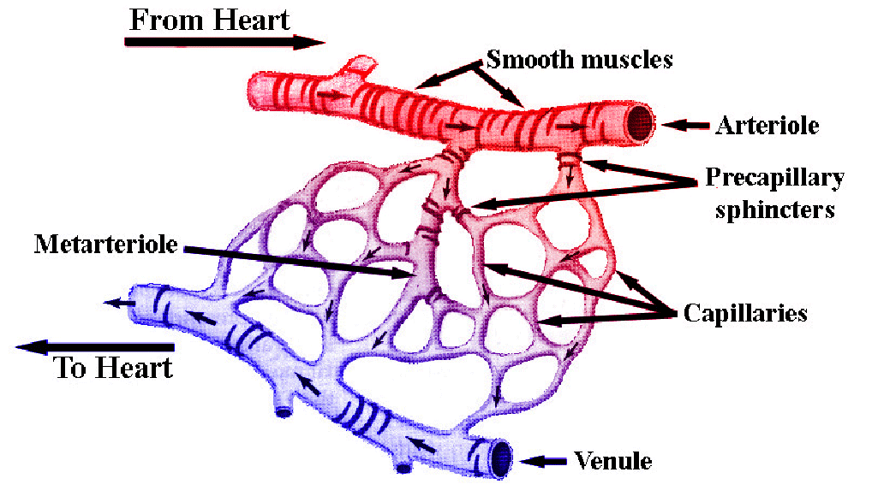

Capillary bed

- Differences between arteries and veins:
- Arterial blood is under more pressure than venous blood.
*Arteries spurt, veins ooze.
- The walls of arteries are thicker than the walls of veins.
- Veins have valves that prevent backflow.
*less pressure and against gravity
*common site of blood clots
- “Arteries pump, veins dump”

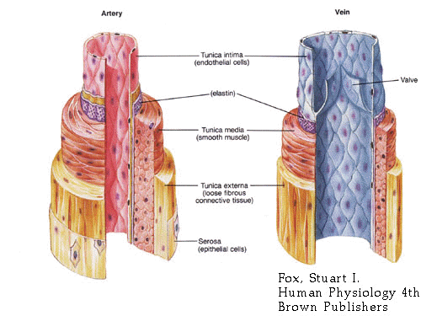
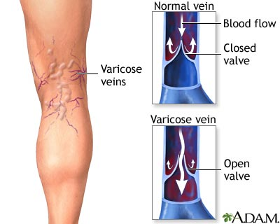
artery
vein

