VI. Blood
- The vehicle that the cardiovascular system uses to
transport materials throughout the body:
- Gases
- Nutrients
- Wastes
- Heat

- Physical characteristics:
- Scarlet (O₂-rich/arteries) to dull red (O₂-poor/veins)
- Heavier and 5x thicker than water
- Narrow pH range: 7.35-7.45
- 100.4°F (warmer than body)
- 5-6 liters (8% of total body weight)

- Considered to be connective tissue.

living cells surrounded by nonliving extracellular matrix

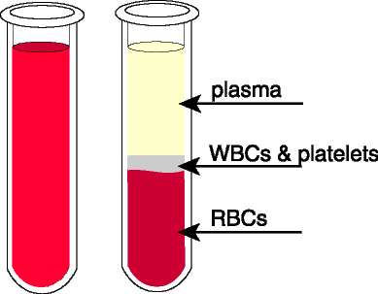
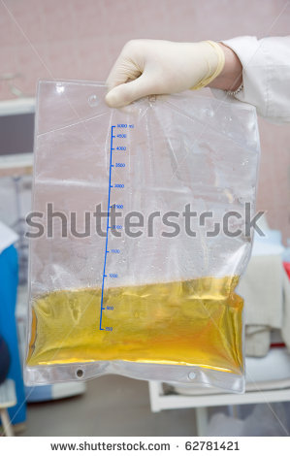
- Plasma (the nonliving extracellular matrix)
- 90% water
- 100’s of things dissolved in it
- Plasma proteins:
- Albumin – keeps correct amount of water in
the blood
- Antibodies – protection from pathogens
- Clotting proteins – control blood loss

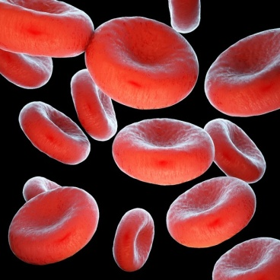
- Formed Elements (the living cells in the plasma)
- Erythrocytes (RBS’s)
- the most abundant F.E.
- last about 120 days
- no nucleus
- carry O₂ on hemoglobin (a protein with iron)
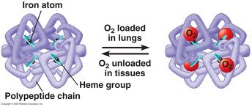

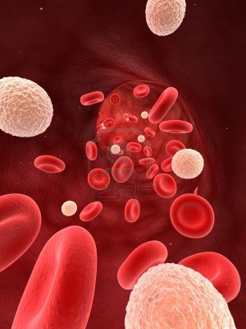
- Leucocytes (WBC’s)
- Fight disease
- Respond to chemicals given off by infected tissue
- Leukocytosis – elevated WBC count which
indicates disease or infection.

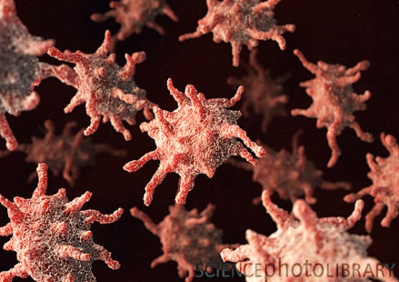
- Platelets
- Irregular-shaped cell
fragments.

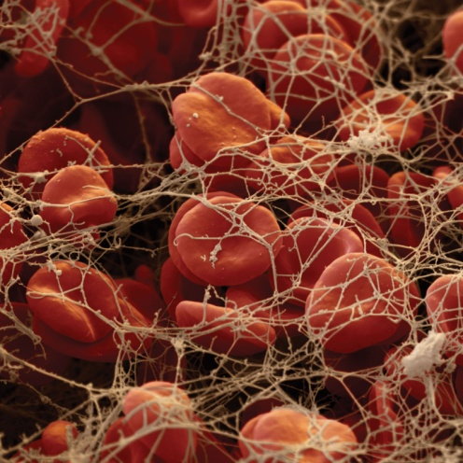
- Hemostasis (blood clotting):
  - Cling to ruptured tunica intima of vessel (usually very smooth but rough when injured)
  - Plug causes vessel to spasm and constrict
  - Protein “fibrin” forms which traps RBC’s to make clot
  - Usually takes 3-6 minutes

