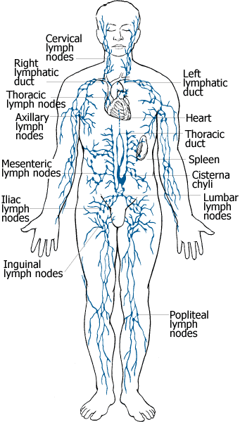
VII. Lymphatic System (ch12)

- Two major functions
- Immunity (houses many infection-
fighting cells)

- Returns fluid lost from blood back
to the heart.
*Up to 3 liters of watery fluid
called “lymph” leaks through
the blood vessels into the
surrounding tissues every day.

- Two basic parts to this system:
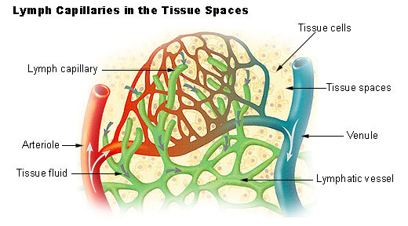
- Lymphatic Vessels
- One-way system of capillaries that take fluid from tissues back to the heart (via subclavian veins).

- Very permeable to fluid called “lymph”.
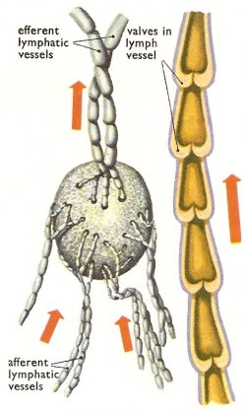

- Lymph pumped back to heart by “milking” action of skeletal muscles.

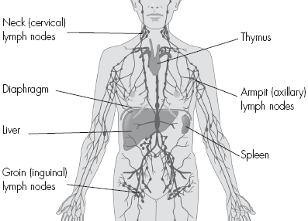
- Lymphoid Organs

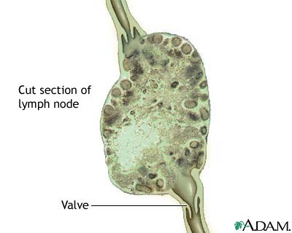
- Organs with Immunity functions:
- lymph nodes
- thymus gland
- tonsils

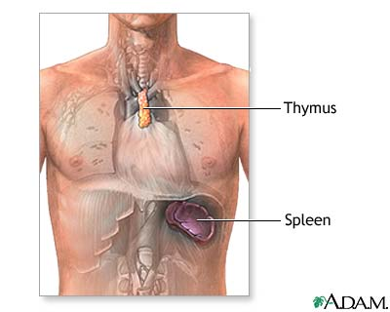
- Cardiovascular functions:
- Spleen
  - filters blood
  - destroys worn-out RBC’s
  - recycles iron
  - stores platelets
  - blood reservoir

