VIII. Cardiovascular System Disorders
A. Anemia – blood does not carry enough oxygen.
1. Sickle Cell Anemia – misshaped RBC’s
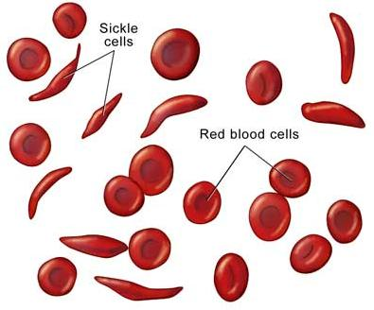

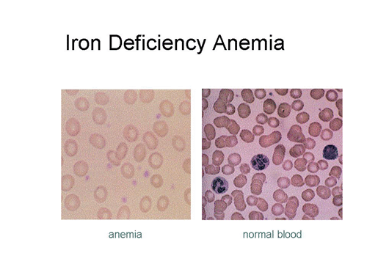

Smaller & Paler

2. Iron Deficient Anemia – not enough Fe to carry O₂

B. Arteriosclerosis
1. Thickening and toughening of artery wall.
2. Usually caused by build-up of fats (called “plaque”)
from high blood cholesterol levels.
3. Reduced blood supply can result in heart attack.
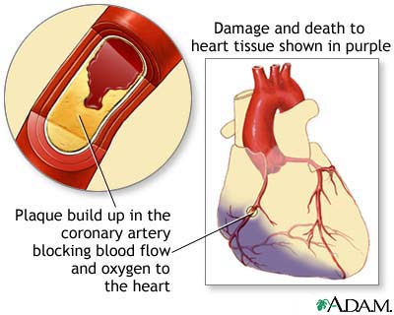
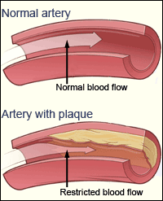

C. Heart Attack (myocardial infarction)
1. Blood supply to heart is blocked.
2. Cardiac muscle cells that die off are not replaced.
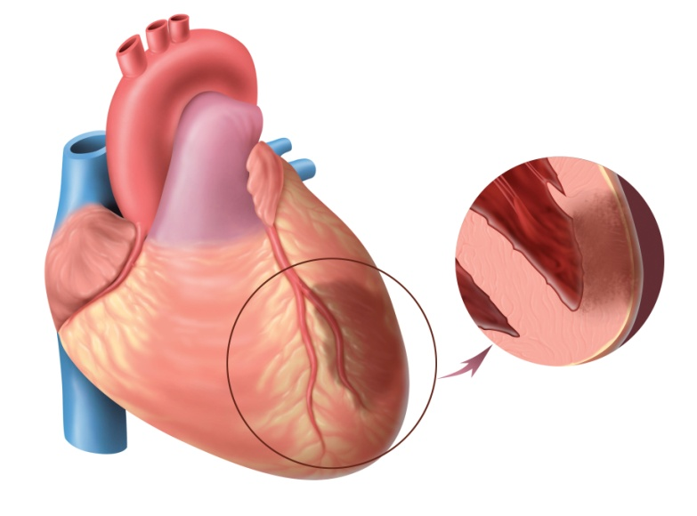
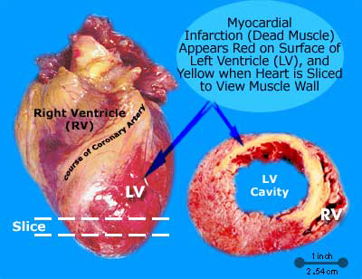

Myocardial Infarction

D. Congestive Heart Failure
1. Heart is too weak to deliver adequate blood to body.
2. Infections, toxins, high BP can weaken heart.
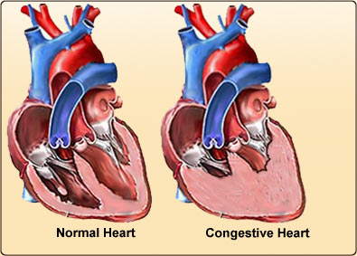

E. Aneurysm
1. Bulge in blood vessel.
2. No symptoms until burst, then catastrophic.
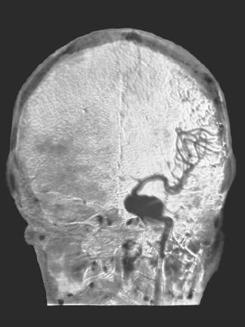
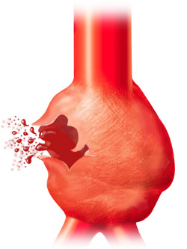
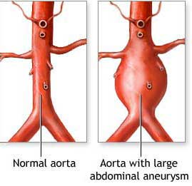

F. Edema – blocked lymph vessels
