Why does cell division happen in living things? | What are 2 reasons that a cell can only get so big? | What happens to a cell when it gets too big?
What are the two main parts of a cell’s life cycle? | What is Interphase and its three stages? | What is Cancer?
What are the 5 steps of Mitosis? | What happens in Prophase? | What happens in Metaphase?
After a cell completes Cytokinesis, what stage of the Cell Cycle does it enter? | What are Sister Chromatids, and in which stage(s) of the cell cycle do we find them? | What are Daughter Chromosomes, and in which stage(s) of the cell cycle do we find them?
What is Chromatin, and in which stages of the cell cycle do we find it? | What happens in each of the 3 stages of Interphase? | What 2 factors control the rate of the Cell Cycle?
What is a Metastasis? | What are Carcinogens? | What are some causes for Cancer?
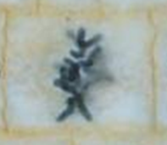  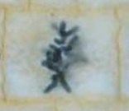  Which stage of the Cell Cycle? | 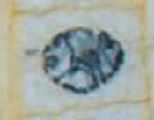  Which stage of the Cell Cycle? | 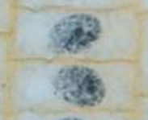  Which stage of the Cell Cycle?
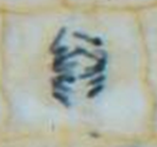  Which stage of the Cell Cycle? | 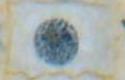  Which stage of the Cell Cycle? | 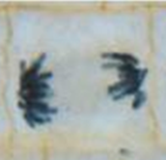  Which stage of the Cell Cycle?
What are three common treatments for Cancer? | What may happen if the genes that produce cyclins get messed up? | When should each type of cancer treatment be used?

What happens in Anaphase? | What happens in Telophase? | What happens in Cytokinesis?
Why does the DNA get copied during S-Interphase? | Why does the nuclear membrane break down during Prophase? | What are the spindle fibers for in Metaphase and Anaphase?
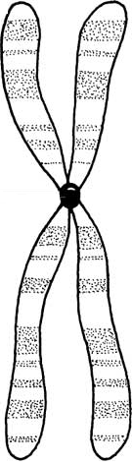  What is this structure? | 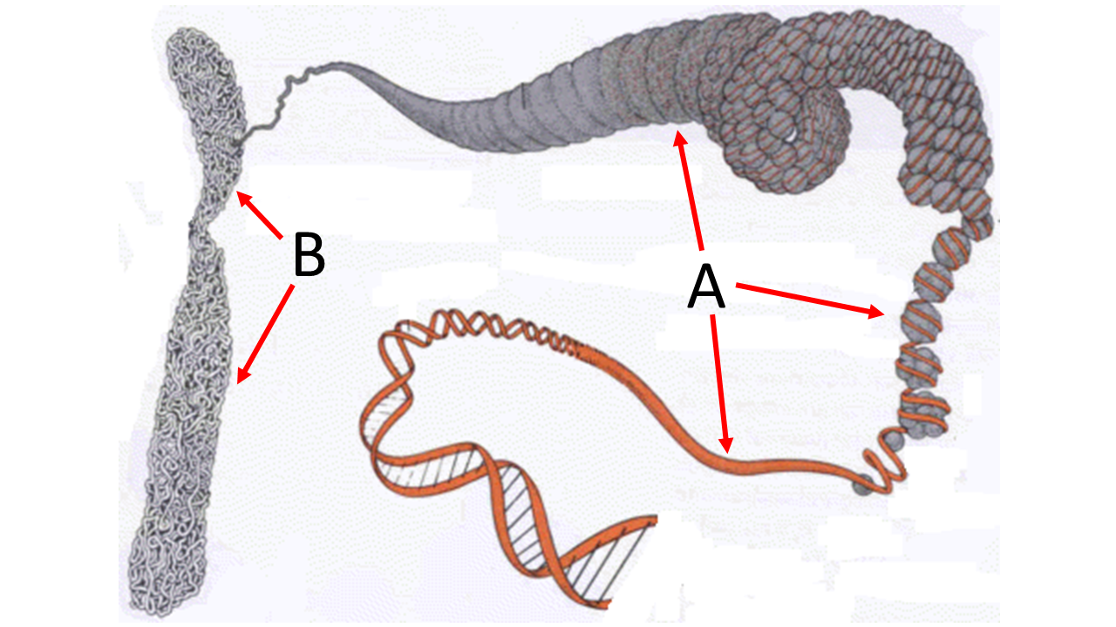  What are each of these structures? | What are structures A and B?

